Experiment – 12
Implement Iris Flower Classification using KNN

Aim
To implement the K-Nearest Neighbors (KNN) algorithm for classifying Iris flowers into three species (Setosa, Versicolor, and Virginica) using the Iris dataset.

Algorithm
- Import the required libraries.
- Load the Iris dataset.
- Split the dataset into training and testing sets.
- Train the KNN classifier.
- Predict the species for the test data.
- Evaluate the model using Accuracy, Confusion Matrix, and Classification Report.
- Predict the species for a new flower sample.

Program:
# Step 1: Import Libraries
import numpy as np
from sklearn.datasets import load_iris
from sklearn.model_selection import train_test_split
from sklearn.neighbors import KNeighborsClassifier
from sklearn.metrics import accuracy_score, confusion_matrix, classification_report

# Step 2: Load Iris Dataset
iris = load_iris()

X = iris.data
y = iris.target

# Step 3: Split Dataset
X_train, X_test, y_train, y_test = train_test_split(
X, y,
test_size=0.2,
random_state=42
)

# Step 4: Create KNN Classifier
knn = KNeighborsClassifier(n_neighbors=3)

# Step 5: Train the Model
knn.fit(X_train, y_train)

# Step 6: Predict Test Data
y_pred = knn.predict(X_test)

# Step 7: Model Evaluation
print("Accuracy:", accuracy_score(y_test, y_pred))

print("\nConfusion Matrix:")
print(confusion_matrix(y_test, y_pred))

print("\nClassification Report:")
print(classification_report(
y_test,
y_pred,
target_names=iris.target_names
))

# Step 8: Predict New Flower
new_flower = [[5.1, 3.5, 1.4, 0.2]]

prediction = knn.predict(new_flower)

print("\nPredicted Flower Species:",
iris.target_names[prediction][0])

Output:
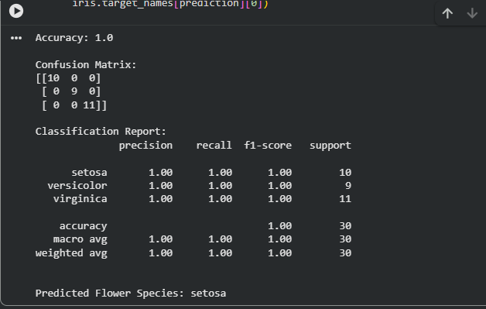

Result
The K-Nearest Neighbors (KNN) algorithm was successfully implemented on the Iris dataset. The model accurately classified the flowers into Setosa, Versicolor, and Virginica species. The model's performance was evaluated using Accuracy, Confusion Matrix, and Classification Report, achieving high classification accuracy on the test dataset.

